

**YEAR 11 ATAR Course Examination**

**Question/Answer Booklet**

**ECONOMICS - Unit 1**

**Semester 1 2018**

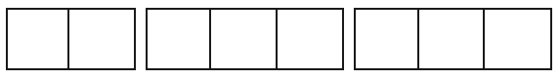

**Student Number:**

**Student Number Written: ______________________________**

**Time allowed for this paper**

Reading time before commencing work: Ten minutes

Working time for paper: 2 hours 30 minutes

**Materials required/recommended for this paper**

***To be provided by the supervisor***

This Question/Answer Booklet

Extended Answer Question/Answer Booklet

Multiple-choice Answer Sheet

***To be provided by the candidate***

Standard items: pens (blue/black preferred), pencils (including coloured), sharpener,

correction fluid/tape, eraser, ruler, highlighters

Special items: non-programmable calculators approved for use in the ATAR examinations

**Important note to candidates**

No other items may be taken into the examination room. It is **your** responsibility to ensure that you do not have any unauthorised material. If you have any unauthorised material with you, hand it to the supervisor **before** reading any further.

|  |  |  |  |  |  |
| --- | --- | --- | --- | --- | --- |
| Section | Number of questions available | Number of questions to be answered | Suggested working time (minutes) | Marks available | Final mark as a percentage |
| Section one Multiple- Choice | 24 | 24 | 30 | 24 |  |
| Section Two  Data Interpretation/ Short Answer | 3 | 3 | 80 | 36 |  |
| Section Three Extended Answer | 2 | 1 | 40 | 20 |  |
|  |  |  | Total | 80 |  |

**Instructions to candidates**

1. Answer the questions according to the following instructions.

Section One: Answer all questions on the separate Multiple-choice answer sheet provided. For each question, shade in the correct answer. Use only a blue or black pen. If you make a mistake, place a cross through that square, then select your new answer. Do not erase or use correction fluid/tape. Marks will not be deducted for incorrect answers. No marks will be given if more than one answer is completed for any question.

Section Two: Write your answer in this Question/Answer Booklet

Section Three: Write your answers in the Extended Answer Question/Answer Booklet.

2. You must be careful to confine your answers to the specific questions asked and to follow any instructions that are specific to a particular question.

3. Supplementary pages for the use of planning/continuing your answer to a question have been provided at the end of this Question/Answer booklet. If you use these pages to continue an answer, indicate at the original answer where the answer is continued, i.e. give the page number.

**Section 1: Multiple-choice (24 Marks)**

This section has **24** questions. Answer **all** questions on the separate Multiple-choice answer sheet provided. For each question, shade in the correct answer. Use only a blue or black pen to shade the boxes. If you make a mistake, place a cross through that square, then select your new answer. Do not erase or use correction fluid/tape. Marks will not be deducted for incorrect answers. No marks will be given if more than one answer is completed for any question.

Suggested working time: 30 minutes

___________________________________________________________________________________

1. The law of demand includes the statement ‘other things being equal’. These other things include all of the following except
   1. the price of that good.
   2. consumers’ income.
   3. consumers’ tastes and preferences.
   4. the number of potential buyers.
2. ‘Market equilibrium’ can only be achieved
   1. after successful government intervention in the market.
   2. when the good is no longer relatively scarce.
   3. when the quantity supplied is equal to the quantity demanded at market price.
   4. when there are an equal number of buyers and sellers in the market.

The following diagram illustrates the market for pet ferrets.

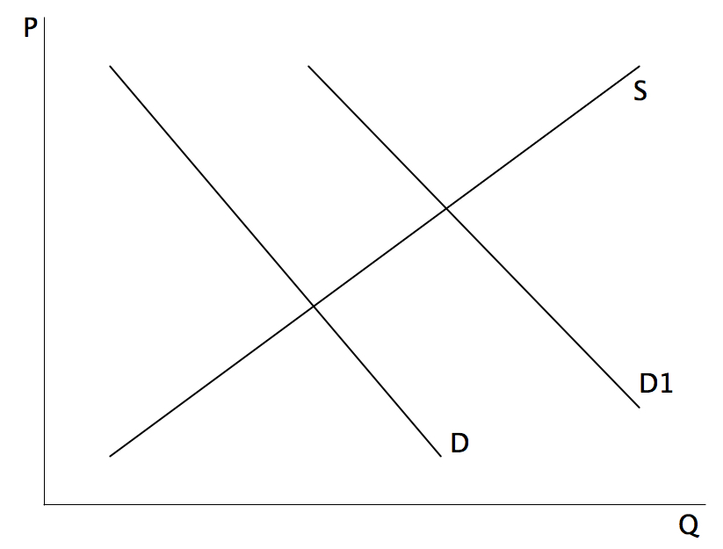

1. The shift in demand from D to D1 is best explained by
   1. an increase in the availability of pet ferrets.
   2. a change in pet preferences from weasels to ferrets.
   3. a decrease in the price of pet ferrets.
   4. an increase in the price of pet ferrets.
2. For a normal good, an increase in consumer income will lead to
   * 1. A rightward shift in the demand curve
     2. An increase in supply
     3. A movement down the demand curve
3. i only.
4. ii only.
5. iii only.
6. Both ii and iii.
7. Total revenue will fall as a result of a price rise when elasticity of demand is
   1. less than unitary elastic.
   2. unitary elastic.
   3. zero.
   4. more than unitary elastic.
8. Goods and services that have government taxes levied on them tend to be
   1. income inelastic.
   2. income elastic.
   3. Price elastic.
   4. price inelastic.
9. Consumer surplus is best defined as
   1. the marginal benefit from purchasing the last unit of the good sold.
   2. the difference between the marginal benefit and the price paid for that unit of the good.
   3. equal to the price paid for the last unit of the good sold.
   4. the sum of the marginal benefit and the price paid for the last unit sold.

Question 8 refers to the figure below.

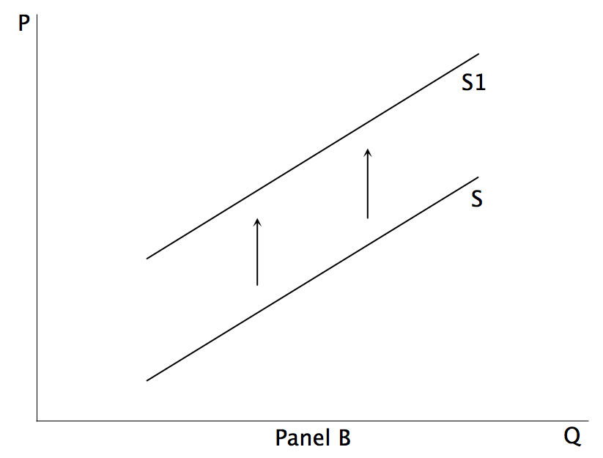

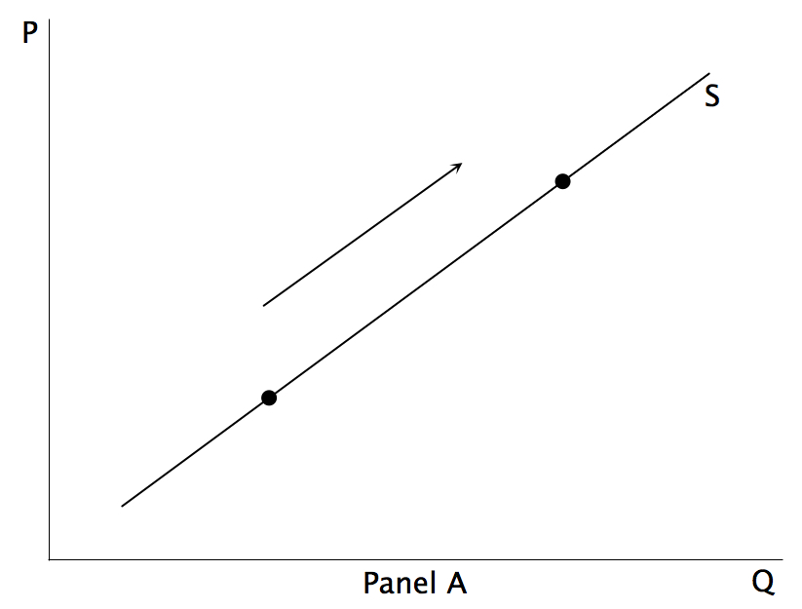

1. Which of the following statements is true?
   1. Panel A shows an increase in supply and Panel B shows a decrease in supply.
   2. Both Panels A and B show an increase in quantity supplied.
   3. Panel A shows and expansion of quantity supplied and Panel B shows a decrease in quantity supplied.
   4. Panel A shows an expansion in quantity supplied and Panel B shows a contraction in supply.
2. A deadweight loss occurs in a market if
   1. quantity is not at equilibrium.
   2. economic welfare is maximised.
   3. quantity fails to cover producers’ costs.
   4. total surplus is maximised.
3. If a price floor is placed on wool produced in Australia, this will lead to
   1. a decrease in consumer surplus.
   2. a decrease in producer surplus.
   3. a shortage of wool produced in Australia.
   4. an improvement in economic efficiency.
4. In comparison to firms in a competitive market, a firm with market power will
   1. produce less of a good and sell it at a lower price.
   2. produce less of a good and sell it at a higher price.
   3. produce more of a good and sell it at a higher price.
   4. produce more of a good and sell it at a lower price.
5. Public education is funded by the government, and is an example of a
   1. private good.
   2. private service.
   3. merit good.
   4. public service.
6. The price of pizza rises from $5 to $6 and the quantity consumed falls from 2015 units to 1060 units. The price elasticity coefficient is _____ and the pizza is _____ in demand.
   1. 2.4; inelastic.
   2. 2.4; elastic.
   3. 0.4; inelastic.
   4. 0.4; elastic.
7. Woolworths Homebrand products would have an income elasticity that is
   1. Inferior good
   2. Normal good.
   3. Perfectly inelastic good.
   4. Luxury good.
8. The government is thinking of introducing a new tax on one of the following products. On which of these goods would consumers’ least prefer an addition tax?

|  |  |
| --- | --- |
| ***Price elasticity of demand*** | |
| *Donuts* | *0.4* |
| *Pizza* | *0.8* |
| *Ice cream* | *1.6* |
| *Smoothies* | *2.0* |

* 1. Donuts
  2. Pizza
  3. Ice cream
  4. Smoothies

1. Roses are more expensive on Valentine’s Day than at other times of the year, yet sales of roses are highest on that day. How does economic theory account for this?
   1. People buying the roses are irrational.
   2. Roses are not subject to the law of demand.
   3. Suppliers decrease the supply of roses to increase the price.
   4. An increase in demand increases the market clearing price of roses.
2. Which combination is most likely to result in the demand for a product being highly price elastic?

|  |  |  |
| --- | --- | --- |
|  | **Number of close substitutes** | **% of income spent on product** |
| a) | Large | Large |
| b) | Large | Small |
| c) | Small | Large |
| d) | Small | Small |

1. Compared to the price elasticity of demand for petrol in general, the demand for a particular brand of petrol is
   1. inelastic because demand for each brand keeps on rising as population grows and becomes more affluent.
   2. inelastic because in the short term there is no effective substitute for petrol.
   3. elastic because if the price of one brand rises, consumers will buy other brands which are close substitutes.
   4. elastic because if the price of one brand falls, sellers of other brands will reduce their price to avoid losing market share.
2. What happens to the consumer surplus for ice creams as price rises because of a change in supply?
   1. it decreases if elasticity is greater than one
   2. it increases if elasticity is greater than one.
   3. it decreases regardless of elasticity.
   4. it increases regardless of elasticity.
3. The ‘tragedy of the commons’ results from
   1. the overuse of private goods.
   2. the loss of land once used for the common good.
   3. the lack of government expenditure on welfare.
   4. the overuse of common property goods.
4. The exhaust fumes pollution created by driving motor vehicles is an example of a situation in which
   1. there is overproduction, social costs are less than private costs.
   2. there is underproduction, social benefits are less than private costs.
   3. there is overconsumption, social benefits are less than private benefits.
   4. there is underconsumption, social benefits are more than private benefits.

Questions **22 and 23** refer to the graph below which illustrates the market for rental housing.

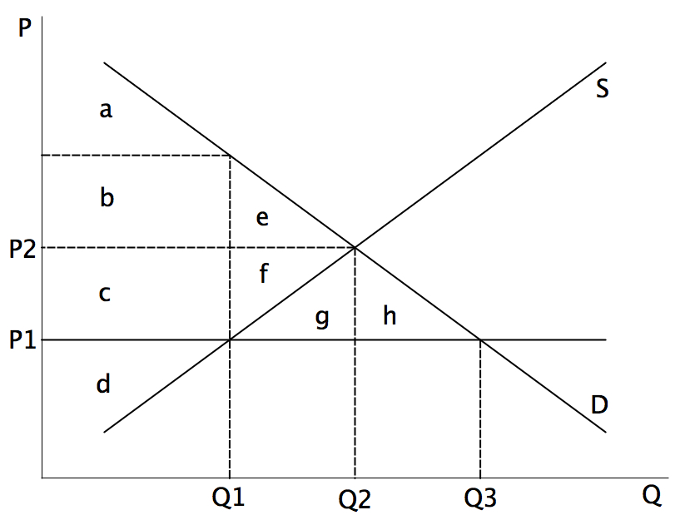

1. The government sets a maximum price for rent at P1. This would result in a deadweight loss equivalent to
   1. d
   2. a to f
   3. e + f
   4. g + h
2. In the diagram above, at price P1, there is a ______ of rental houses equivalent to _______.
   1. shortage; Q2 – Q3.
   2. shortage; Q1 – Q3
   3. surplus; Q2 - Q3
   4. surplus; Q1 – Q3
3. The relationship between equity and efficiency is best explained by saying that
   1. equity is about maximizing surpluses whilst efficiency is about minimizing marginal cost.
   2. equity relates to horizontal issues whilst efficiency relates to vertical issues.
   3. equity and efficiency both aim to reduce deadweight loss.
   4. equity relates to distribution whilst efficiency relates to production.

**Section Two: Data interpretation / Short answer (36 Marks)**

This section contains **three (3)** questions. Answer **all** questions. Write your answers in the spaces provided.

Supplementary pages for the use of planning/continuing your answer to a question have been provided at the end of this Question/Answer booklet. If you use these pages to continue an answer, indicate at the original answer where the answer is continued, i.e. give the page number.

Suggested working time: 80 minutes.

___________________________________________________________________________________

**Question 25 (12 marks)**

Refer to the following diagram showing the market for potatoes to answer the following questions.

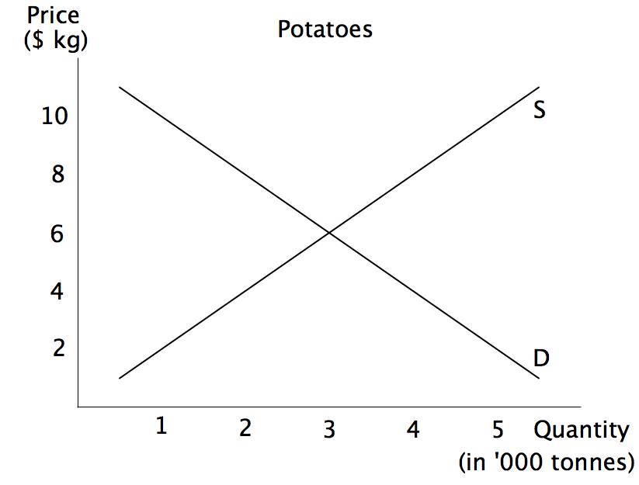

|  |  |  |
| --- | --- | --- |
| a) | Identify why the supply curve is upward sloping from left to right. | (1 mark) |
|  |  |  |
|  |  |  |
|  |  |  |
|  |  |  |

|  |  |  |
| --- | --- | --- |
| b) | Define Price Elasticity of Demand. | (1 mark) |
|  |  |  |
|  |  |  |
|  |  |  |
|  |  |  |

|  |  |  |  |
| --- | --- | --- | --- |
| c) | Calculate the price elasticity of demand for potatoes when price moves from $4 per kg to $6 per kg and state if it is elastic or inelastic. | | (2 marks) |
|  |  | |  |
|  | Calculation: |  |  |
|  |  |  |  |
|  |  |  |  |
|  |  |  |  |
|  |  |  |  |
|  |  |  |  |
|  |  |  |  |
|  |  |  |  |

|  |  |  |
| --- | --- | --- |
| d) | Using information from part c, explain the significance of the price elasticity of demand co-efficient for the producer. | (3 marks) |
|  |  |  |
|  |  |  |
|  |  |  |
|  |  |  |
|  |  |  |
|  |  |  |
|  |  |  |
|  |  |  |
|  |  |  |
|  |  |  |
|  |  |  |
|  |  |  |
|  |  |  |
|  |  |  |
|  |  |  |
|  |  |  |
|  |  |  |

|  |  |  |  |
| --- | --- | --- | --- |
| e) | The government legislates to introduce a price floor in the market for potatoes. With the aid of a diagram explain how a price floor creates a deadweight loss and interferes with the efficiency of the market for potatoes. | | (5 marks) |
|  |  | |  |
|  |  |  |  |
|  |  |  |  |
|  |  |  |  |
|  |  |  |  |
|  |  |  |  |
|  |  |  |  |
|  |  |  |  |
|  |  |  |  |
|  |  |  |  |
|  |  |  |  |
|  |  |  |  |
|  |  |  |  |
|  |  | |  |
|  |  | |  |
|  |  | |  |
|  |  | |  |
|  |  | |  |
|  |  | |  |
|  |  | |  |
|  |  | |  |
|  |  | |  |
|  |  | |  |
|  |  | |  |
|  |  | |  |
|  |  | |  |
|  |  | |  |
|  |  | |  |
|  |  | |  |
|  |  | |  |

This page has been left blank intentionally

Please turn over the page for the next question.

**Question 26 (12 marks)**

This question refers to the following extract.

**Retailers pray for rainy day, with warm weather hurting winter sales**

If you think it's been unseasonably warm across southern Australia this autumn — you'd be right. Official Bureau of Meteorology figures show temperature records have been smashed in New South Wales, Victoria and South Australia.

So, spare a thought for retailers, for whom the unusual weather is having a massive financial impact. "Everybody is saying 'isn't this weather amazing' — I'm saying 'no we want some cold weather it's not amazing at all'," said Anita Carmody, the owner of Swish Plus Fashion, a chain of nine retail stores. Winter stock has been out on the floor since February and few people are buying. "It's definitely affecting sales— foot traffic is down," Ms Carmody said. "The consistent heat doesn't encourage people to go out and buy a winter wardrobe."

While online sales have been steady, instore figures have fallen by almost 10 per cent on last year, Ms Carmody said.

"When the introduction of the winter stock came into Myer in particular, within the first week they had 20 per cent off their woollen garments," said Judy Wawszkowicz, the owner of Lola's Boutique in western Sydney. The boutique has $20,000 worth of winter stock on the floor, but many shoppers are still asking for summer clothes. However, buying more summer stock to meet demand isn't an option as the lead time for orders is a year.

By business reporter [Emily Stewart](http://www.abc.net.au/news/emily-stewart/4506536) ABC News 19 April 2018

|  |  |  |
| --- | --- | --- |
| a) | Identify from the article one factor which is affecting the supply for summer clothing. | (1 mark) |
|  |  |  |
|  |  |  |
|  |  |  |
|  |  |  |

|  |  |  |
| --- | --- | --- |
| b) | Using examples, identify a product and factor market. | (2 marks) |
|  |  |  |
|  |  |  |
|  |  |  |
|  |  |  |
|  |  |  |
|  |  |  |
|  |  |  |
|  |  |  |

|  |  |  |  |
| --- | --- | --- | --- |
| c) | Describe and demonstrate the impact on the winter clothing market discussed in the article using demand and supply analysis. | | (3 marks) |
|  |  | |  |
|  |  |  |  |
|  |  |  |  |
|  |  |  |  |
|  |  |  |  |
|  |  |  |  |
|  |  |  |  |
|  |  |  |  |
|  |  |  |  |
|  |  |  |  |
|  |  |  |  |
|  |  |  |  |
|  |  | |  |
|  |  | |  |
|  |  | |  |
|  |  | |  |
|  |  | |  |
|  |  | |  |
|  |  | |  |
|  |  | |  |

|  |  |  |
| --- | --- | --- |
| d) | Explain three factors that can affect the demand for winter clothing. | (6 marks) |
|  |  |  |
|  |  |  |
|  |  |  |
|  |  |  |
|  |  |  |
|  |  |  |
|  |  |  |
|  |  |  |
|  |  |  |
|  |  |  |
|  |  |  |
|  |  |  |
|  |  |  |
|  |  |  |
|  |  |  |
|  |  |  |
|  |  |  |
|  |  |  |
|  |  |  |
|  |  |  |
|  |  |  |
|  |  |  |
|  |  |  |
|  |  |  |
|  |  |  |

This page has been left blank intentionally

Please turn over the page for the next question.

**Question 27 (12 marks)**

This question refers to the following extract.

**Sugar tax: why health experts want it but politicians and industry are resisting**

The Australian Medical Association has kicked off debate again, but how does a sugar tax operate? And do they even work?

New calls for Australia to introduce a sugar-sweetened beverages tax have [sparked an outcry from the food and beverage industry and provoked resistance from politicians](https://www.theguardian.com/australia-news/2018/jan/08/health-experts-support-sugar-tax-as-coalition-calls-for-personal-responsibility). But why do health experts keep calling for a sugar sweetened beverages (SSB) tax, and why are politicians and industry resisting it? This can be answered easily because of the nature of sugary drinks having a fairly high elasticity.

**Why target drinks?**

According to Prof Tim Gill, from the Boden Institute of Obesity, Nutrition, Exercise & Eating Disorders in Sydney, the strength of an SSB tax is it targets an easily defined product.

“It’s easy to identify sugary drinks and their manufacturers, and you can tax them at their production,” he said. “There are a limited number of sugary drinks producers in Australia. A bugbear for governments collecting taxes can be how complicated it can be. if you were to try to tax every sugary food for example, that would be very complicated to do.”

Bureau of Statistics [data shows Australia is one of the 10 highest soft drink-consuming countries per capita](http://www.abs.gov.au/ausstats/abs@.nsf/Lookup/by%20Subject/4364.0.55.007~2011-12~Main%20Features~Consumption%20of%20Sweetened%20Beverages~710). The World Health Organisation recommends adults consume no more than six teaspoons of sugar per day, but the average Australian consumes more than double that. A 330ml bottle of Coke contains nine teaspoons of sugar.

(Extract from: The Guardian – Melissa Davey 10 January, 2018)

|  |  |  |
| --- | --- | --- |
| a) | Explain why the consumption of soft drinks could be considered to be a demerit good. | (2 marks) |
|  |  |  |
|  |  |  |
|  |  |  |
|  |  |  |
|  |  |  |
|  |  |  |
|  |  |  |
|  |  |  |

|  |  |  |  |
| --- | --- | --- | --- |
| b) | Demonstrate and explain how a negative production externality creates inefficiency in the market. | | (4 marks) |
|  |  | |  |
|  |  |  |  |
|  |  |  |  |
|  |  |  |  |
|  |  |  |  |
|  |  |  |  |
|  |  |  |  |
|  |  |  |  |
|  |  |  |  |
|  |  |  |  |
|  |  |  |  |
|  |  |  |  |
|  |  |  |  |
|  |  | |  |
|  |  | |  |
|  |  | |  |
|  |  | |  |
|  |  | |  |
|  |  | |  |
|  |  | |  |
|  |  | |  |
|  |  | |  |
|  |  | |  |
|  |  | |  |

|  |  |  |  |
| --- | --- | --- | --- |
| c) | Using the information from the article, explain how the impact of a sugar tax affects consumers and producers. | | (6 marks) |
|  |  | |  |
|  |  |  |  |
|  |  |  |  |
|  |  |  |  |
|  |  |  |  |
|  |  |  |  |
|  |  |  |  |
|  |  |  |  |
|  |  |  |  |
|  |  |  |  |
|  |  |  |  |
|  |  |  |  |
|  |  |  |  |
|  |  | |  |
|  |  | |  |
|  |  | |  |
|  |  | |  |
|  |  | |  |
|  |  | |  |
|  |  | |  |
|  |  | |  |
|  |  | |  |
|  |  | |  |
|  |  | |  |
|  |  | |  |
|  |  | |  |
|  |  | |  |
|  |  | |  |
|  |  | |  |
|  |  | |  |
|  |  | |  |
|  |  | |  |

**Section Three: Extended Answer (20 marks)**

This section contains **two (2)** questions. Answer **one (1)** question. Write your answer in the Extended Answer Question/Answer Booklet provided and number your answer clearly.

Suggested working time: 40 minutes.

___________________________________________________________________________________

**Question 28 (20 marks)**

1. Demonstrate and explain why competitive markets are the most efficient markets.

(6 marks)

1. Using an appropriate example, demonstrate and explain how firms with market power can impact on efficiency and equity.

(8 marks)

1. Explain the role and purpose of the Australian Competition and Consumer Commission (ACCC) in preventing business practices that reduce competition.

(6 marks)

**Question 29 (20 marks)**

1. Discuss **three** factors that would cause the demand for a good to be relatively price elastic.

(6 marks)

1. Explain the meaning of price elasticity of supply and, using a diagram(s), distinguish between price elastic and price inelastic supply.

(6 marks)

1. Explain how economists use the concept of elasticity to distinguish between normal and inferior goods **and** between substitutes and complements.

(8 marks)

|  |  |  |
| --- | --- | --- |
| Supplementary Writing Page | |  |
|  |  |  |
|  |  |  |
|  |  |  |
|  |  |  |
|  |  |  |
|  |  |  |
|  |  |  |
|  |  |  |
|  |  |  |
|  |  |  |
|  |  |  |
|  |  |  |
|  |  |  |
|  |  |  |
|  |  |  |
|  |  |  |
|  |  |  |
|  |  |  |
|  |  |  |
|  |  |  |
|  |  |  |
|  |  |  |
|  |  |  |
|  |  |  |
|  |  |  |
|  |  |  |
|  |  |  |
|  |  |  |
|  |  |  |
|  |  |  |
|  |  |  |
|  |  |  |
|  |  |  |
|  |  |  |
|  |  |  |
|  |  |  |

|  |  |  |
| --- | --- | --- |
| Supplementary Writing Page | |  |
|  |  |  |
|  |  |  |
|  |  |  |
|  |  |  |
|  |  |  |
|  |  |  |
|  |  |  |
|  |  |  |
|  |  |  |
|  |  |  |
|  |  |  |
|  |  |  |
|  |  |  |
|  |  |  |
|  |  |  |
|  |  |  |
|  |  |  |
|  |  |  |
|  |  |  |
|  |  |  |
|  |  |  |
|  |  |  |
|  |  |  |
|  |  |  |
|  |  |  |
|  |  |  |
|  |  |  |
|  |  |  |
|  |  |  |
|  |  |  |
|  |  |  |
|  |  |  |
|  |  |  |
|  |  |  |
|  |  |  |
|  |  |  |

|  |  |  |
| --- | --- | --- |
| Supplementary Writing Page | |  |
|  |  |  |
|  |  |  |
|  |  |  |
|  |  |  |
|  |  |  |
|  |  |  |
|  |  |  |
|  |  |  |
|  |  |  |
|  |  |  |
|  |  |  |
|  |  |  |
|  |  |  |
|  |  |  |
|  |  |  |
|  |  |  |
|  |  |  |
|  |  |  |
|  |  |  |
|  |  |  |
|  |  |  |
|  |  |  |
|  |  |  |
|  |  |  |
|  |  |  |
|  |  |  |
|  |  |  |
|  |  |  |
|  |  |  |
|  |  |  |
|  |  |  |
|  |  |  |
|  |  |  |
|  |  |  |
|  |  |  |
|  |  |  |